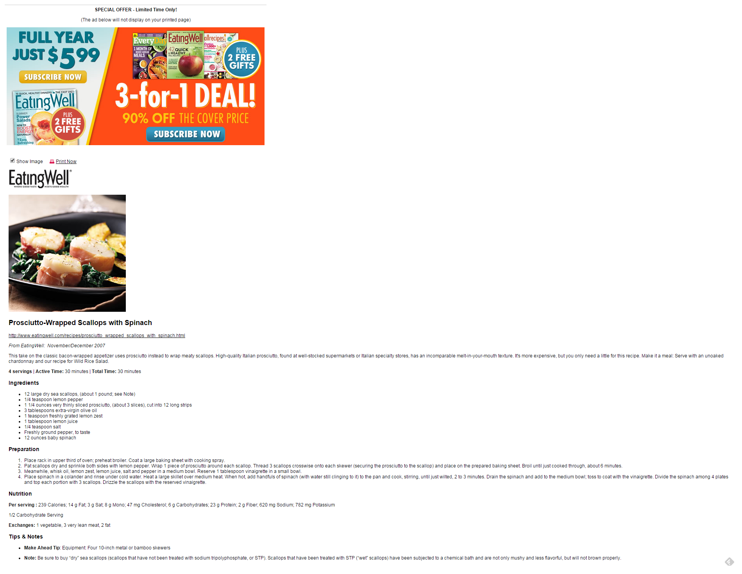
SPECIAL OFFER-Limited Time Only:
(The ad below will not display on your printed page)
FULLYEAR JUST $599
.
3-for-D
ధౌ |
SUBSCRIBE NOW
* Show Image E. Print.Now
EatingWel|
-------------- --.сосн.--
Prosciutto-Wrapped Scallops with Spinach
http://www.eatingwell.com|recipes prosciutto wrapped scallops with spinach.html From Eating Well: November/December 2007
LL LLL LLLLLLLL LLLLLSLLLLL LLLLLLLLLLL LLLLLL LLLLLLL LL LLL LLLLLS LLLLLLS LLLLLSLLLLLLL LLLLL LLLLLLLLS LLLL LLLLLSLLLLLL LLLLLLLL LLLLLLL LLLLLLL LLLLS LLL LL LLLLLLLLL LLLLLSLLSLLLLSLLL LLLLLLS LLL LLL LLLLLLLS LLLL LL LLL LLL LLLLL LLLLLLS LLLLLLLLS LLLL LLL LL LLLL chardonnay and our recipe for Wild Rice Salad.
4 servings |Active Time: 30 minutes|TotalTime: 30 minutes
Ingredients
12 large dry sea stallops, (about 1 pound; see Note) 1/4 teaspoon lemon pepper 1 1/4 ounces verythinly sliced prosciutto, (about3.slices), cutinto 12 longstrips 3tablespoons extra-virgin olive oil
1 teaspoon freshlygrated lemonzest
1 tablesp00m lemonjuite
1/4 teaspoon salt
Freshlyground pepper, to taste
12 ounces baby spinach
Preparation
Place rackin upper third of Owen; preheatbroiler. Coatalarge baking sheet with cooking spray. LLLLLLLL LL LLL LLLLLL LLLL LLLL LLL LLLLL LLLLLLS LLL 0 LLLLL LLLLLLLL LLLLLL LLLL LLLLLLS LLLLLL 0 LLLLLL LLLLL LL LLLL LLLLL LLLLLL LLL LLLLLLL LL LLL LLLLSLLLL LLLLLL LLLLLLL LLLLLL LLLS LLL LLL LLLLLLLLL LLLLLS LLL0 LLLLLS Meanwhile, whiskoil, lemonzest, lemon juice, salt and pepper in a medium bowl. Reserve 1 tablespoonvinaigrette in a small bowl. LLLL LLLLL LLLLLLLLLLLL LLL LLLLLLL LLLLS LLLLLLLL LLLLLLLLLL LLLLLL LLS LLL LLS LL LLLLL LL LLLLLL SLL LLLLL LL LLLLLL LL L L LL LLL LL L00LS LLLLS LL LLLLLLLLS 0 L 0 LLLLLLS LLLLL LLLLLL LL LLLL LL LLLLLL LLLLS LLL L LLLLLLL LLL LLLLLLS LLLLL LLL LLLLLLLL 0 LLLS and top each portion with 3 stallops. Drizzle the stallops with the reserved winaigrette.
i
Nutrition Per serving:239 Calòries; 14 g Fat 3 g Sat 8 g Mömö; 47 mg Cholesterol:6 g Carbohydrates. 23g Protein, 2 g Fiber:620 mg Sodium, 782 mg Potassium 12 Carbohydrate Serving
Exchanges: 1 wegetable, 3 very lean meat. 2 fat
Tips & Notes
• Make Ahead Tip. Equipment Four 10-inch metal or bamboo skewers
S LLLLLS LL LL L LLLLL LL LL LLLLLL LLLLLL LLLLLLL LLLLL LLLLL LLL LLLL LLLLLLLLLLSS LLLLLS LLLLLLLLLL LLLL LLL LLLL LLL SLLL LLLLLLS LLL LLLL LLLLLLL L LLLLLL LLL LLLL LL LLLLL LLLLLL LL LLL LLLLLLLLS LLLLL LLLLLLL LLLLLLS o

